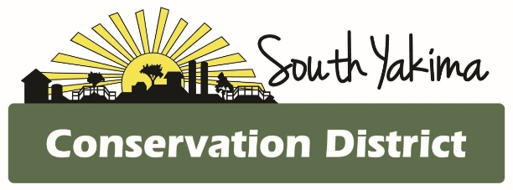
BOARD MEETING AGENDA
Wednesday April 9th, 2025
4:00 pm
In Person and Zoom meeting

To Join Zoom Meeting:

https://us02web.zoom.us/j/82193527763?pwd=KfbOSE0JMrztbUMBGl0bPM6TubngWW.1
Meeting ID: 821 9352 7763
Passcode: 601332
One tap mobile
+1 253 215 8782 US (Tacoma)
AGENCY REPORTS
- NRCS – Chris Wright
- WSCC – Allisa Carlson
- WACD – Heather Wendt
- YNWRP – Stuart Crane
- Eastern Klickitat/Central Klickitat CD – Loren Meagher
- Benton CD – Kristy Pentico

CALL TO ORDER
- Public Comment*
- March meeting minutes
- Treasurer Report / Presentation of Bills

PROGRAM UPDATES
- Natural Resource Investments (NRI)
- Implementation (IM)
- Livestock (LT)
- Voluntary Stewardship Program (VSP)
- Irrigation Efficiency Grant Program (IE)
- Engineering
- No-Till Drills
- GWMA Implementation
- Salmon Recovery Funding (SRF) and Riparian Grant Program (RGP)
- Alternative Manure Management (AMM)
- Lower Yakima Valley Nutrient Assessment and Planning Program (LYVNAPP)

NEW BUSINESS
- WADE Conference scholarships

OFFICE
- Office cleaning service
- AGOL updates
- Other staff updates

*At the request of South Yakima Conservation District Board of Supervisors: The public shall please reserve any comments or questions to 3 minutes in duration. If additional time is required, topics may be included on future agendas and at future meetings. Thank you.

