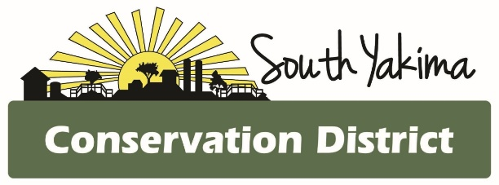
BOARD MEETING AGENDA
Wednesday March 4th, 2026
4:00 pm
In Person and Zoom meeting

To Join Zoom Meeting:

https://us02web.zoom.us/j/81694995224?pwd=XlR4Po6QkuKI6145F5T8WkSNiWt14x.1
Meeting ID: 816 9499 5224
Passcode: 381176
One tap mobile
+12532158782

AGENCY REPORTS
- NRCS – Chris Wright
- WSCC – Allisa Carlson
- Eastern Klickitat/Central Klickitat CD – Loren Meagher
- Benton CD – Kristy Pentico
- Heritage Gardens – Mikki Boughton

CALL TO ORDER
- Public Comments*
- February meeting minutes
- Treasurer Report / Presentation of Bills

BOARD REPORT
- Updates on district projects and programs

NEW BUSINESS

- Legislative Day News
- NACD TA Grant Application
- NACD Annual Meeting 2027
- Local Workgroup Meeting
- May SCC Tour and Dinner update

OFFICE

- Staff Wages
- Annual work plan
- Election reminder
- NACD Annual meeting 2027

*At the request of South Yakima Conservation District Board of Supervisors: The public shall please hold any comments or questions to three minutes in duration. If additional time is required, topics may be included on future agendas for future meetings
Thank you.

