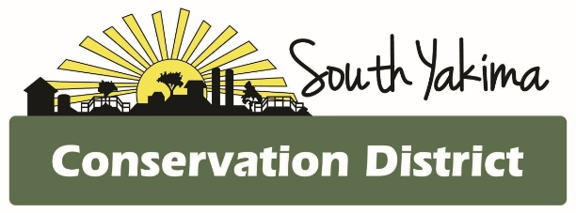
SPECIAL BOARD MEETING AGENDA
Wednesday October 22, 2025
4:00 pm
In Person and Zoom meeting

To Join Zoom Meeting:
https://us02web.zoom.us/j/83803808309?pwd=ZJUHF8GEXK8B6yHZibCYrbBUickh1z.1
Meeting ID: 838 0380 8309
Passcode: 287485
One tap mobile
+1 253 215 8782, 838 0380 8309# *287485# US (Tacoma)

AGENCY REPORTS
- NRCS – Chris Wright
- WSCC – Allisa Carlson
- YNWRP – Stuart Crane
- Eastern Klickitat/Central Klickitat CD – Loren Meagher
- Benton CD – Kristy Pentico, Marcela Appel
- Mikki Boughton-Heritage Gardens

CALL TO ORDER
- Public Comments*
- September meeting minutes
- Treasurer Report / Presentation of Bills

BOARD REPORT
- Updates on district programs, projects and funding
- Action items

NEW BUSINESS

- S.C.A.M. Attendee list

OFFICE
- Staff evaluations

*At the request of South Yakima Conservation District Board of Supervisors: The public shall please hold any comments or questions to three minutes in duration. If additional time is required, topics may be included on future agendas for future meetings.
Thank you.

