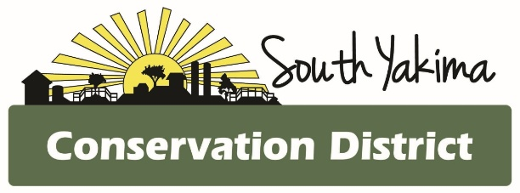
BOARD MEETING AGENDA
Wednesday January 7th, 2026
4:00 pm
In Person and Zoom meeting

To Join Zoom Meeting:

https://us02web.zoom.us/j/81726634119?pwd=Y7ixeFqZji8RZWGyRgXfak2hrEdsTI.1
Meeting ID: 817 2663 4119
Passcode: 280847

Join By Phone
1- 253- 215- 8782 # US (Tacoma)

AGENCY REPORTS
- NRCS – Chris Wright
- WSCC – Allisa Carlson
- YNWRP – Stuart Crane (retired)
- Eastern Klickitat/Central Klickitat CD – Loren Meagher
- Benton CD – Kristy Pentico
- Heritage Gardens – Mikki Boughton

CALL TO ORDER
- Public Comments*
- December meeting minutes
- Treasurer Report / Presentation of Bills

BOARD REPORT
- Updates on district projects and programs
- Action items

NEW BUSINESS
- Tax Assessment Resolution
- Monthly Bills Resolution
- Board Attendance Discussion
- NACD TA Grant Application
- Annual work plan
- Legislative Day
- May 19-21 WSCC Meeting Tour and Dinner

OFFICE

- Audit Update
- Staff Wages
- Annual Work Plan
- Web Page Updates

*At the request of South Yakima Conservation District Board of Supervisors: The public shall please hold any comments or questions to three minutes in duration. If additional time is required, topics may be included on future agendas for future meetings
Thank you.

