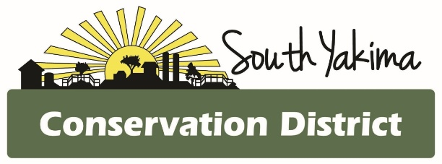
SPECIAL BOARD MEETING AGENDA
Wednesday November 25th, 2025
4:00 pm
In Person and Zoom meeting

To Join Zoom Meeting:

https://us02web.zoom.us/j/87012333958?pwd=uwfvQWIDObUhyqwdaa1bxQvt4QY5yg.1

Meeting ID: 870 1233 3958
Passcode: 862714

To Call in
12532050468,,87012333958#,,,,*862714# US
+12532158782,,87012333958#,,,,*862714# US (Tacoma)

AGENCY REPORTS
- NRCS – Chris Wright
- WSCC – Allisa Carlson
- YNWRP – Stuart Crane
- Eastern Klickitat/Central Klickitat CD – Loren Meagher
- Benton CD – Kristy Pentico, Marcela Appel
- Mikki Boughton-Heritage Gardens

CALL TO ORDER
- Public Comments*
- October meeting minutes
- Treasurer Report / Presentation of Bills

BOARD REPORT
- Updates on district projects and programs
- Action items

NEW BUSINESS
- WACD annual meeting online Dec 1-3

OFFICE

- Staff evaluation

*At the request of South Yakima Conservation District Board of Supervisors: The public shall please hold any comments or questions to three minutes in duration. If additional time is required, topics may be included on future agendas for future meetings.
Thank you.

